**TRICYCLE**

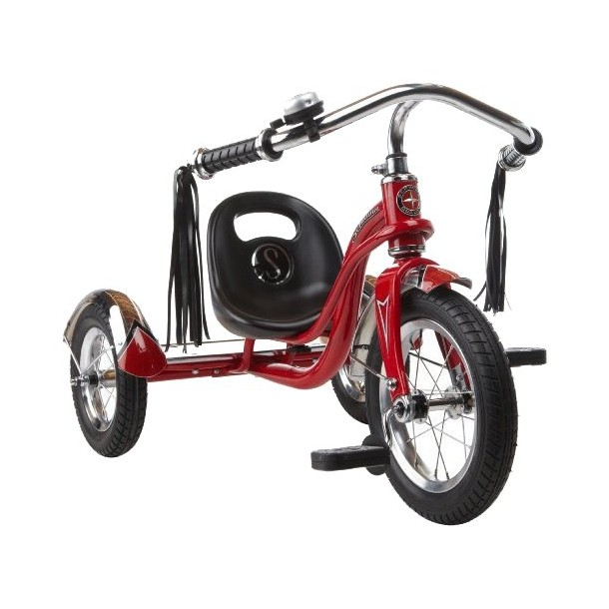

Schwinn Roadster 12" Trike - Red

RM 97.99

Tricycle has an adjustable saddle for growing kids and real air tires for a smooth ride

* Includes a sturdy steel frame with rear wood deck, chrome fenders and rims and cruiser-style handlebars with bell
* Assembly required
* For ages 1.5–3 yrs.
* Material: Steel

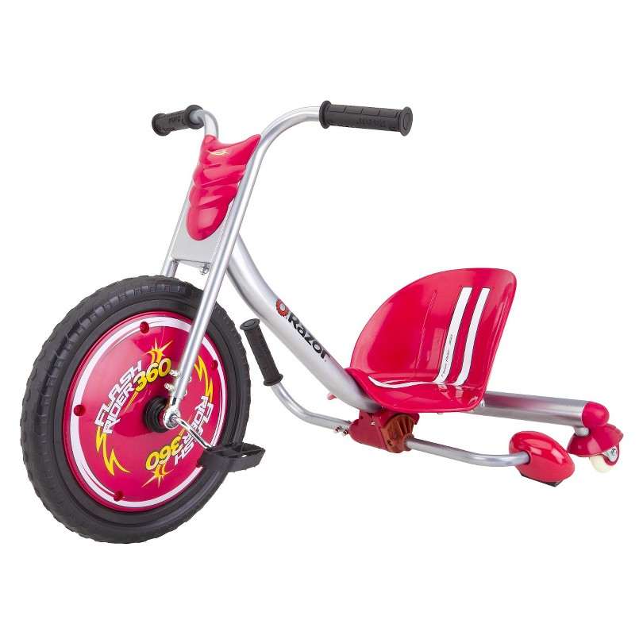

Razor Flash Rider 360 Trike - Red

PRICE : RM 95.00

* **Manufacturer's Suggested Age:** 6 Years and Up
* **Maximum Weight Capacity:** 160.0 Lb.
* **Material:** Steel, Plastic, Rubber
* **Assembly Details:** assembly required, tools provided

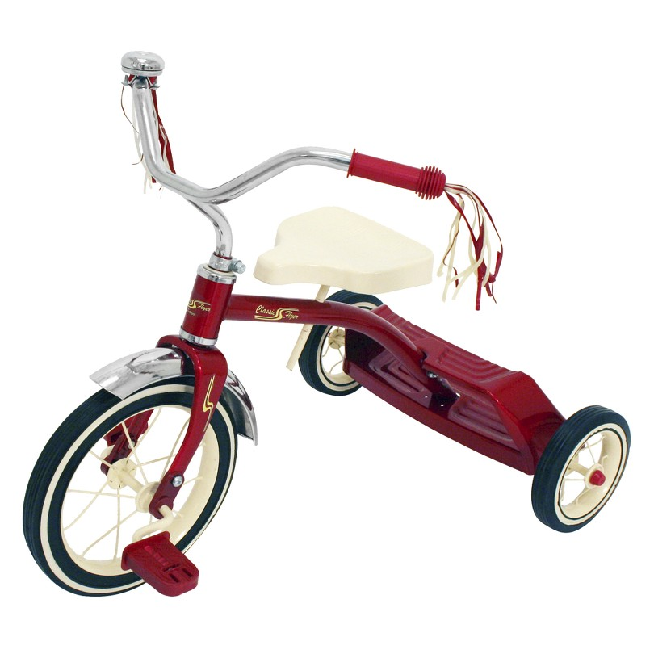

Kettler Kid's Classic Flyer 12" Tricycle - Red

PRICE : RM 61.99

**SCOOTER**

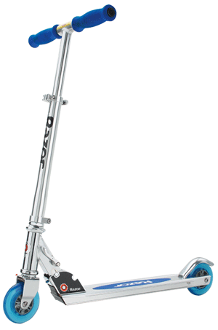

Razor A Scooter

RM 39.99

Easy to fold and carry

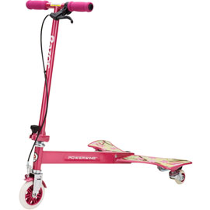

Razor Powerwing Sweet Pea Scooter

RM 129.99

Maximum rider weight is 143 pounds and Slammin 360

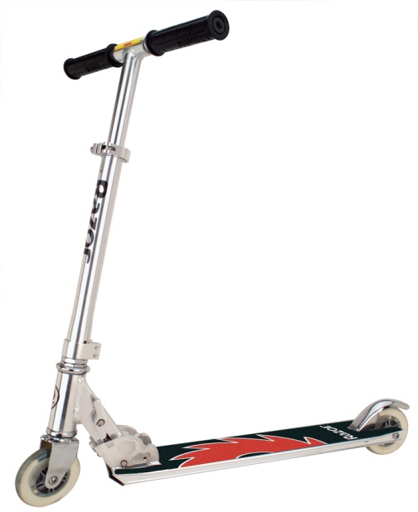

Razor Pro Model Scooter

RM 59.99

Assembled Product Dimensions: 25.5" x 4" x 7.25"

**TOLOCAR**

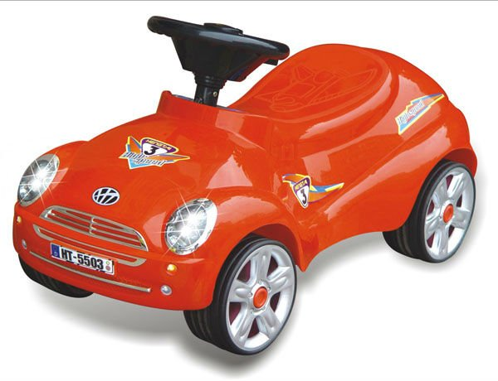

Tolocar Chipolino

Cart for riding and pushing.

Suitable for children from 2 to 5 years.

Maximum load to 27 kg.

Stimulates the motor system and coordination of the child.

Age: 2-5 years

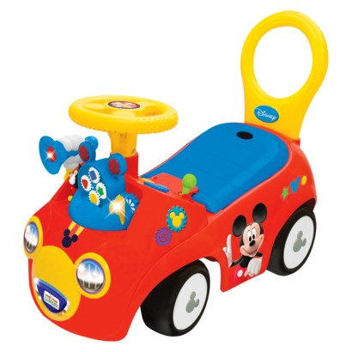

Disney Mickey Playtime Ride On - Red Disney

Price RM 44.99

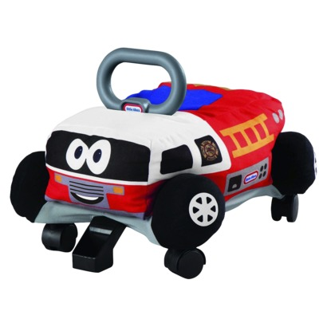

MGA Entertainment Pillow Racers Fire Truck

Price $39.99